**Jason**

Study according to the case given by the youtuber. Ruff Times run an annual subscription.

Financial Accounting (The process) => Financial Transaction => Financial Statement

* Recording
* Summarising
* Analysing

Step of Financial Accounting: **(Accounting Cycle)**

1. **Identify Transaction:** For example, annual subs (subs yearly) and gain 40k
2. **Prepare Journal Entry:** A record of a financial transaction
3. **Post to General Ledger:**
4. **Unadjusted Trial Balance:**
5. **Post Adjusting Entries:**
6. **Adjusted Trial Balance:**
7. **Create Financial Statements:**
8. **Post Closing Entries**

**Financial Accounting Core Principle: ACCOUNTING EQUATION**

**STUFF YOUR BUSINESS OWNS = STUFF YOUR BUSINESS OWES**

Stuff Your Business Owns:

* Assets = Resources that i will benefit from in the future (Cash and Inventory)

Stuff Your Business Owes:

* Liabilities (For Third Parties) = Owes stuff to third parties lenders or suppliers = Obligation that you need to fulfill in the future)
* Equity (For Owners) = Claim on the business net assets

Credits and Debits: (Double Entry Accounting)

* Credits = The sources that economic benefit flows from
* Debits = Destination that the economic benefit flows to

So from the subscription example. I **DEBIT CASH** to increase **ASSETS** and I **CREDIT SUBSCRIPTION REVENUE** to record my income

General Ledger = A database that stores a complete record of all accounts & journal entries

Account = Place where we record, sort, & store all financial transactions that affect a related group of items. There is 6 types of account:

* Assets
* Liabilities
* Equity:
  + Revenue
  + Expenses
  + Withdrawal / Dividends

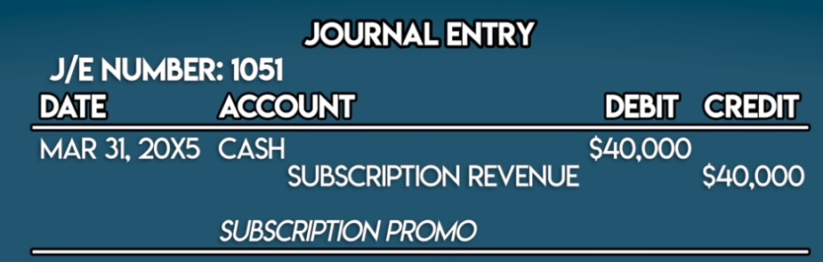

The Journal entry shown above affect 2 Accounts (T - Account). Debit on the left and Credit on the right.

Trial balance = Internal report that summarize the closing numbers / balances of all General Ledger Accounts. It helps with checking error and making financial statements.

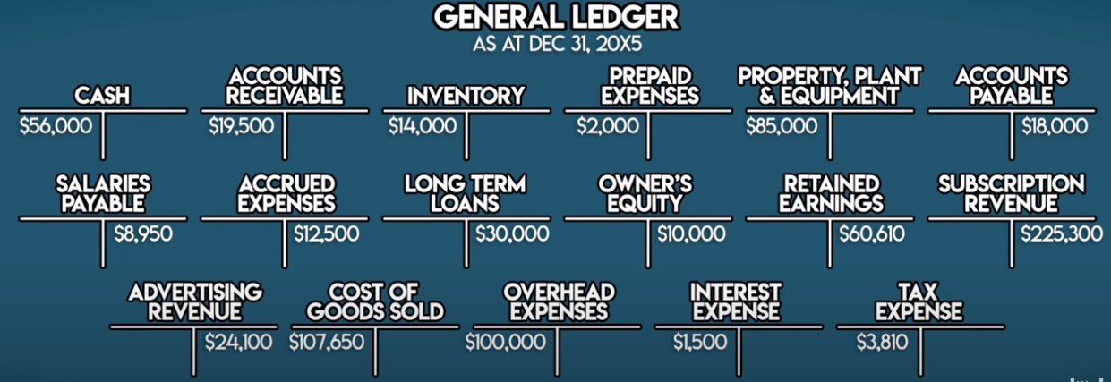

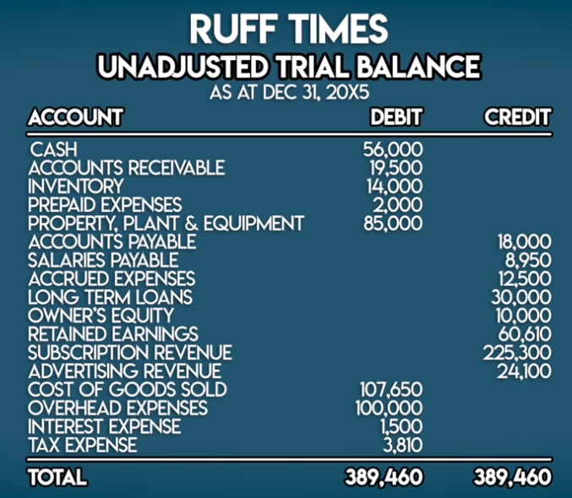

General Ledger -> Unadjusted Trial Balance

To check if debit and credit are in balance or not.

Adjusting Entries = Journal entries posted at the end of an accounting period to bring a business’s book in line with the accrual method of accounting.

International Financial Reporting Standards (IFRS) or Generally Accepted Accounting Principles (GAAP) = Make sure our financial statements reflect a fair view of business.

Accrual Method = Revenue is recognised as it’s earned and Expenses are recorded as they are incurred

From my understanding, **Cash accounting** is when we recognize revenue as we received the money and record expenses as we paid it out. But the problem is, receiving cash is not the same as earning revenue. For example in this annual subscription, We get the cash from the start, but we actually earned the money in the span of 1 year. This is called the **Accrual Method**.

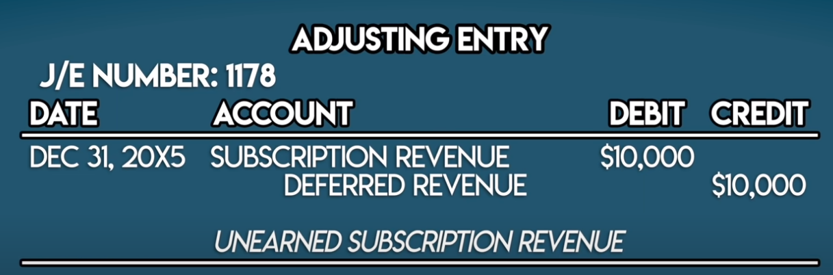

To fix riff times unadjusted trial balance, we just need to reverse 3 out of 12 months of subscription revenue because ruff times started at march. We also temporarily holding it as liability in an account called deferred revenue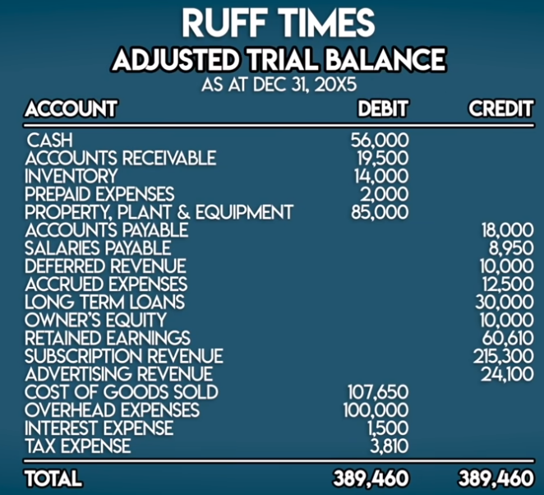

Now we can see that the left and right hand side is still the same. Because we subtract the subscription revenue and keep it as liability in an account called deferred revenue.

Financial Statements = Accounting reports that summarise a business’s activities over a period of time. This is external reports to let investors, lenders, and creditors an understanding of your business’s financial health. 3 main financial statements includes:



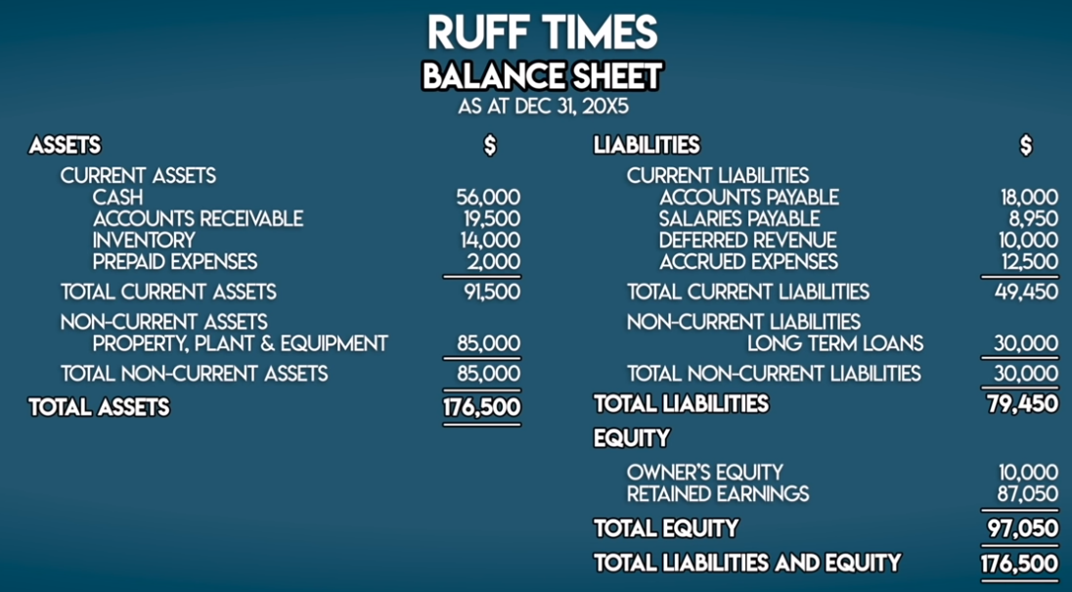

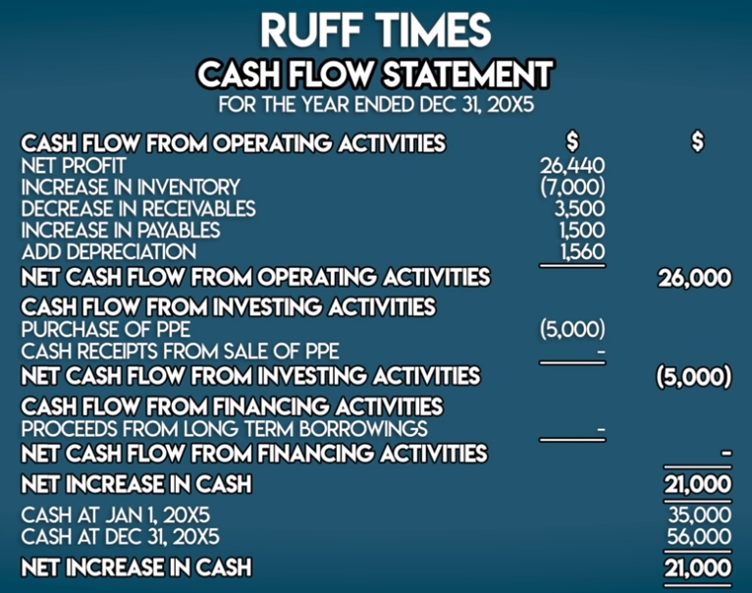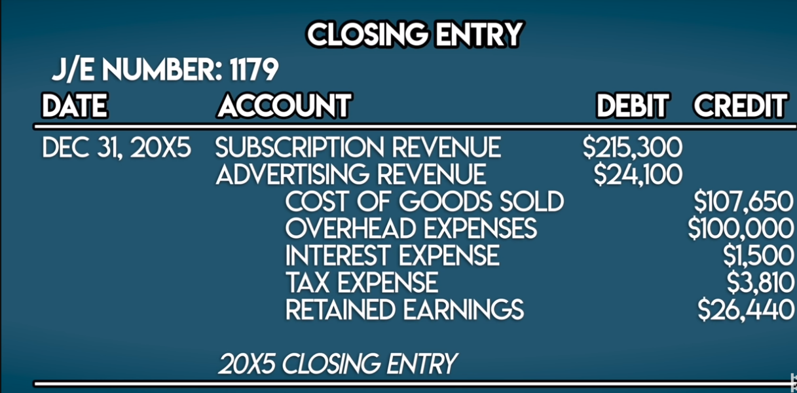

* Balance Sheet = Snapshot of business assets, liabilities, and equity at a single point in time. We can see what we own and owe at the end of the financial year
* Income Statement = Summarize business revenues and expenses over a period of time
* Cash Flow Statement = Keep track of cash flow. Cash Flow Statement summarize your cash inflows and outflows over the same period of time

All of this can be made with adjusted trial balance

Closing Entry = A journal entry that transfers balanced from temporary accounts to permanent accounts in the balance sheet.

Brandy:

**Financial accounting**

Process of identifying, recording, summarizing, analyzing someone’s financial transaction and reporting them in a form called financial statements.

**Journal entry**

Record of financial transaction.

Eg.

J/E NUMBER: 1051

DATE ACCOUNT DEBIT CREDIT

—--------------------------------------------------------------------------------------

MAR 31, XXXX CASH $40.000

SUBSCRIPTION REVENUE $40.000

SUBSCRIPTION PROMO

**Core principle of financial accounting**

Stuff we own such as assets is equal to the stuff we owe such as, liability and equity.

Assets **=** liability + equity.

**Note :**

**A**ssets **are** resources that will benefit us in the future such as cash and inventory.

**L**iability **is** stuff we owe from third parties lender.

**E**quity **is** what represents our claim on the business net.

**Double entry accounting**

**Credit** represents the sources that economic benefit flows from.

**Debit** represents the destinations that it flows to.

**General ledger**

The place where we store all our financial data such as journal entry.

Eg.

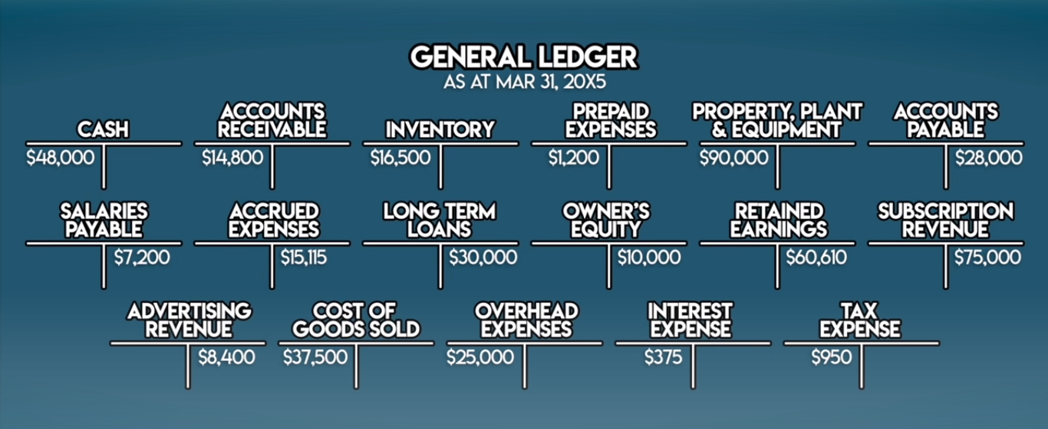

**Account**

The place where we record, sort and store all financial transactions that affect a related group of items.

**Parts of equity**

Dividends :

Revenue

Expenses

Withdrawals

**Trial balance**An accounting report showing the closing balances of all general ledger accounts you have. Generally used to make your financial statements.

**Eg.**

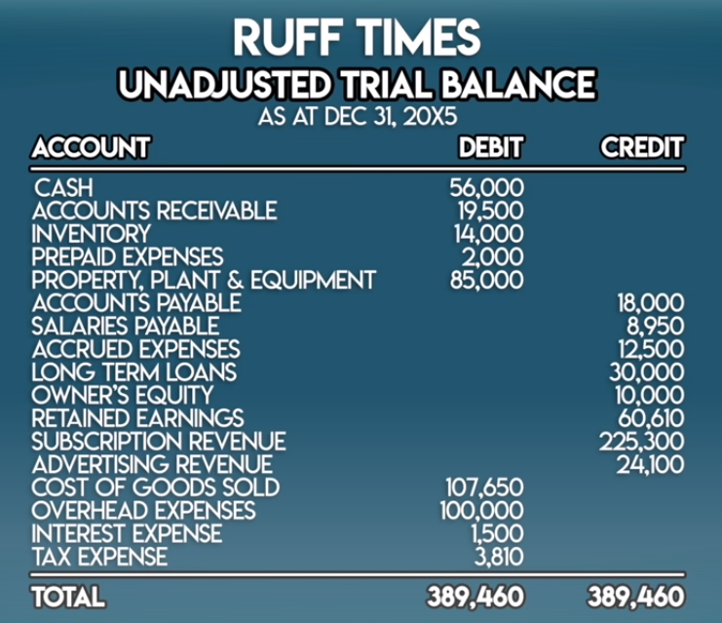

**Adjusting entries**

Journal entries posted at the end of an accounting period to bring a business’s books in line with the accrual method of accounting.

Accrual method : revenue is recognized as its earned expenses are recorded as they are incurred.

In cash accounting, we recognize revenue as we receive cash and record out expenses as we pay them out.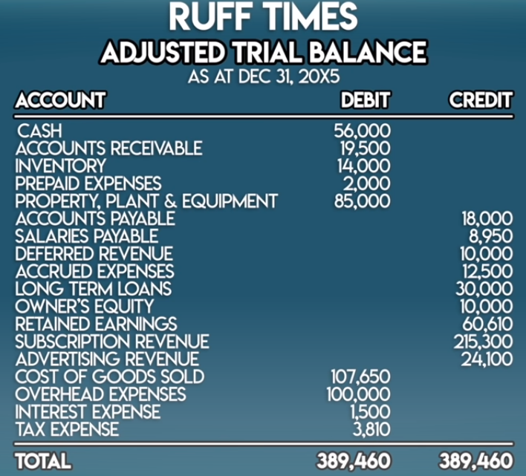

**Financial statements**

Accounting reports that summarize a business’s activities over a period of time.

**3 main financial statements:**

**Balance sheet :**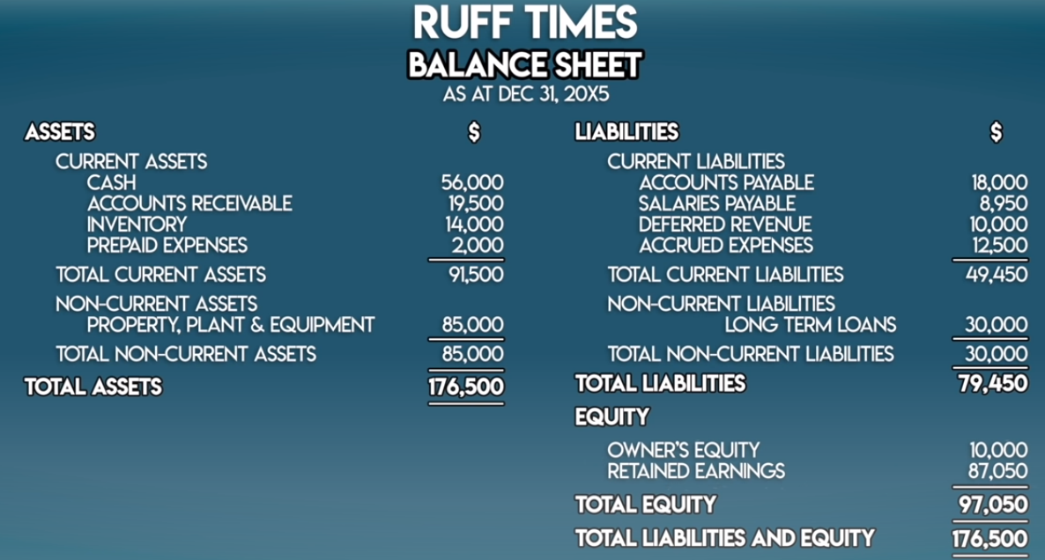

**Income statement :**

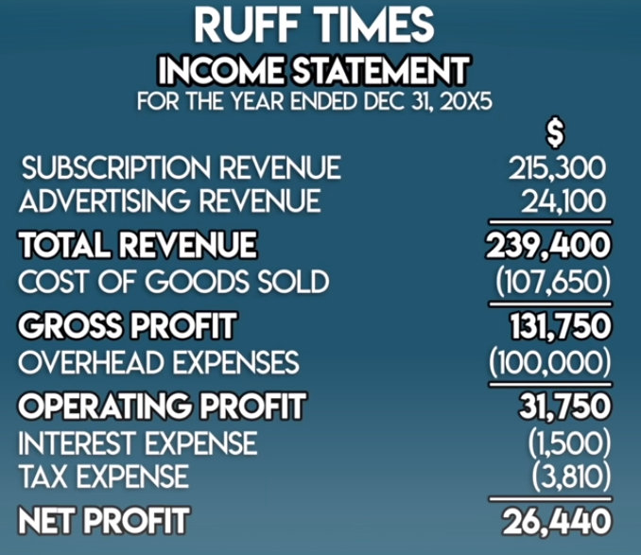

**Cash Flow statement :**

**Closing entry**

A journal entry that transfers balances from temporary accounts to permanent accounts in the balance sheet.

